Version 1.0 November 2002
CERN – EP Division – Microelectronics Group
Matthieu Despeisse
Ausias Garrigos
Giovanni Annelli

AFP_CMOS8 24 channels

Chip Description and pad configuration

1. Introduction

The AFP_CMOS8 chip is an experimental chip to test the behaviour of an Active Feedback Preamplifier (AFP) in a 0.13 μm CMOS technology. Two different versions of AFP were designed. The two versions present an identical schematic, but different sizes for certain transistors (cascode transistor and current mirror cascode transistor) and for the compensation capacitance. The first version is called afp_standard_channel (fig.1), and the second version is called afp_opt_channel (fig.2). Differences occur for the output node resistance of the cascode stage amplifier leading to faster response for the opt_channel but better dynamic response for the standard_channel.

The chip measures 1.9mm by 1mm, and contains two identical pad rings of 0.5mm by 1.9mm each (fig.3). Each pad ring is composed by 38 pads, and contains 12 channels of one version of AFP. The pad ring on the left has 12 AFP_standard channels, and the pad ring on the right has 12 AFP_opt channels (fig.3).

2. Channels

The basic design of one channel consists of 2 horizontal metal lines: the top one for Vdd and the bottom one for gnd. The transistors are placed between them. External biases are brought to the channels by 7 vertical metal lines. The inputs are on the left side of the channels, and the outputs on the right side (fig.4). 4 levels of metal are used for the layout of the channels.
The chip can be tested using injection capacitances which are integrated in front of each channel. The injection capacitances of the odd-numbered channels are then connected all to one pad (Cal1 or Cal1_b), as well as the injection capacitances of the even-numbered channels (pad Cal2 or Cal2_b). The capacitance value is 50fF. 4fC can therefore be injected with an input step pulse of 80mV on the pad Cal1 or Cal2.
The inputs of the channels are also directly connected on pads In<1> (In_b<1>) to In<12> (In_b<12>). A detector can be connected on these pads and tests can so be performed.

Cal2
Out<8>
Cal1
In<8>
Out<9>
Out<10>
Out<11>
Out<12>
In<9>
In<10>
In<11>
In<12>
Channel 88 8
Channel 10
Channel 9
Channel 11
Channel 12
50fF
50fF
50fF
50fF
50fF

3. Pad Configuration:

The pad configuration is similar for the two pad rings, i.e inputs, ouputs, vdd, gnd, and the various biases needed are in the same position, except for the top and bottom pad rows. The pads name of opt_channel are the pads name of the standard_channel with the extension _b.

To bias the channels, seven external biases are needed for each pad ring:

- 2 voltages (Vcas, Vfeed, or Vcas_b, Vfeed_b)
- 5 gate potentials of current mirrors (Iinp, Ifeed, Istcas, Iout, Iout2, or Iinp_b, Ifeed_b, Icas_b, Iout_b, Iout2_b).

Then, 3 pads per pad ring are used for Vdd (or Vdd_b: the vdd of the two rings are not linked), and 2 for gnd.

All the channels in each pad ring are identical, standard on left part, and opt on right part, and each channel is connected to one input pad (In<1> to In<12>, or In_b<1> to In_b<12>), and one output pad (Out<1> to Out<12> or Out_b<1> to Out_b<12>).

There are 2 pads connected to the injection capacitances, Cal1(Cal1_b) is connected to the injection capacitance of the odd channels, and Cal2 (Cal2_b) is connected to the injection capacitance of the even channels.

In each pad ring decoupling capacitances (in parallel between Vdd and gnd) are placed in the lower part of the chip.

The pad description of the two pad rings follows.

Pad ring on the left

Pad Number | Pad Name | Pad description and comments
1 | Iinp | Gate potential of the current mirror of the input transistor
2 | Ifeed | Gate potential of the current mirror of the feedback transistor
3 | In<1> | Input of channel 1 (detector test)
4 | In<2> | Input of channel 2 (detector test)
5 | In<3> | Input of channel 3 (detector test)
6 | In<4> | Input of channel 4 (detector test)
7 | In<5>
8 | In<6>
9 | In<7>
10 | In<8>
11 | In<9>
12 | In<10>
13 | In<11>
14 | In<12> | Input of channel 12 (detector test)
15 | Vfeed | Gate bias of the feedback transistor
16 | Vcas | Gate bias of the cascode transistor
17 | gnd | one of the 2 gnd pads available (together with 38)
18 | Vdd | one of the 3 Vdd pads available (together with 19 and 37)
19 | Vdd | one of the 3 Vdd pads available (together with 18 and 37)
20 | Cal2 | Input of even channels for electrical test
21 | Cal1 | Input of odd channels for electrical test
22 | Out<12> | Output of channel 12
23 | Out<11> | Output of channel 11
24 | Out<10> | Output of channel 10
25 | Out<9>
26 | Out<8>
27 | Out<7>
28 | Out<6>
29 | Out<5>
30 | Out<4>
31 | Out<3>
32 | Out<2>
33 | Out<1> | Output of channel 1
34 | Iout2 | Gate potential of the current mirror of the input transistor
35 | Iout | Gate potential of the current mirror of the input transistor
36 | Istcas | Gate potential of the current mirror of the input transistor
37 | Vdd | one of the 3 Vdd pads available (together with 18 and 19)
38 | gnd | one of the 2 gnd pads available (together with 17)

Pad ring on the right:

Pad Number | Pad Name | Pad description and comments
1 | Iinp_b | Gate potential of the current mirror of the input transistor
2 | Ifeed_b | Gate potential of the current mirror of the feedback transistor
3 | In_b<1> | Input of opt_channel 1 (detector test)
4 | In_b<2> | Input of opt_channel 2 (detector test)
5 | In_b<3> | Input of opt_channel 3 (detector test)
6 | In_b<4> | Input of opt_channel 4 (detector test)
7 | In_b<5>
8 | In_b<6>
9 | In_b<7>
10 | In_b<8>
11 | In_b<9>
12 | In_b<10>
13 | In_b<11>
14 | In_b<12> | Input of opt_channel 12 (detector test)
15 | Vfeed_b | Gate bias of the feedback transistor
16 | Vcas_b | Gate bias of the cascode transistor
17 | Vdd_b | one of the 3 Vdd_b pads available (together with 18 and 37)
18 | Vdd_b | one of the 3 Vdd_b pads available (together with 17 and 37)
19 | gnd | one of the 2 gnd pads available (together with 36)
20 | Cal2_b | Input of even opt_channels for electrical test
21 | Cal1_b | Input of odd opt_channels for electrical test
22 | Out_b<12> | Output of opt_channel 12
23 | Out_b<11> | Output of opt_channel 11
24 | Out_b<10> | Output of opt_channel 10
25 | Out_b<9>
26 | Out_b<8>
27 | Out_b<7>
28 | Out_b<6>
29 | Out_b<5>
30 | Out_b<4>
31 | Out_b<3>
32 | Out_b<2>
33 | Out_b<1> | Output of opt_channel 1
34 | Iout2_b | Gate potential of the current mirror of the input transistor
35 | Iout_b | Gate potential of the current mirror of the input transistor
36 | gnd | one of the 2 gnd pads available (together with 19)
37 | Vdd | one of the 3 Vdd pads available (together with 18 and 19)
38 | Icas_b | Gate potential of the current mirror of the input transistor

- Simulations

Several simulations have been performed, also on the schematic obtained with post layout extraction. The schematic of the system is shown in fig.5, and results in fig.6 and fig.7.
The optimum biasing conditions are:
Vfeed=800mV, Vcas=900mV, Iin=1.4mA, Iout=0.5mA, Iout2=2.5mA, Ifeed=4.6μA and Icas=200μA.
Ifeed is the bias current for the feedback current mirror. In the bias network, the feedback current mirror transistor has a W/L of 1μm / 3μm, and in the channels, this transistor has a W/L of 8μm / 3μm. In the channels, the feedback current will then be equal to 1/8*Ifeed. This method allows us to use lower currents in the feedback path.

The expected signal at the output of a 3D detector is simulated with a current pulse in parallel with a detector (current input cell).
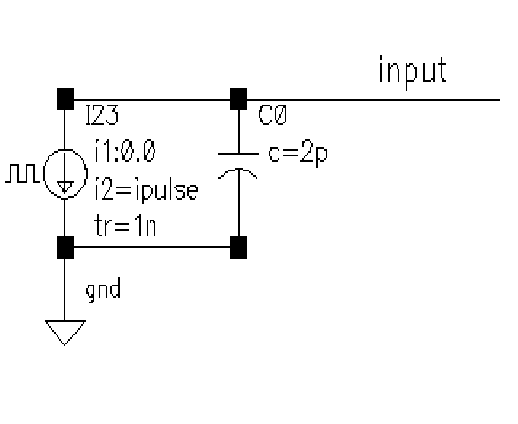
The current pulse has the following shape
1ns rise time
1ns fall time
4μA → 4fC input charge

The Electrical test input is simulated by:
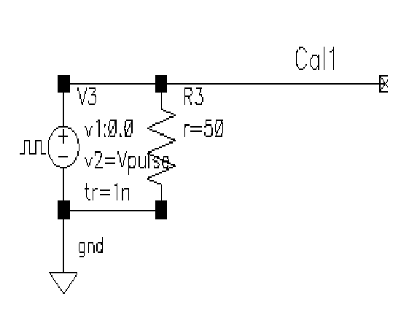

Simulations have been performed using an output readout as follows. It is simulating the effect of pads and oscilloscope:
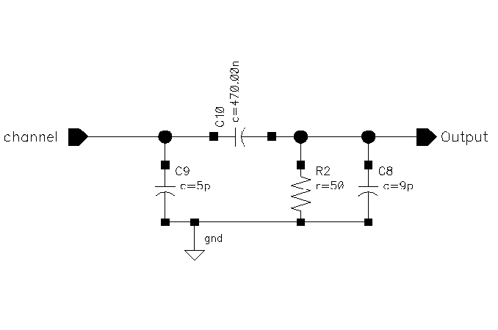

between each channel output and oscillo_out is placed a stage like this one, to simulate
pad and bonding capacitance (5pF), and
oscilloscope charge and capacitance (9pF)

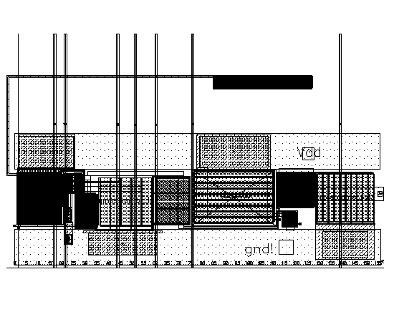
AFP_standard_channel

Injection Capacitance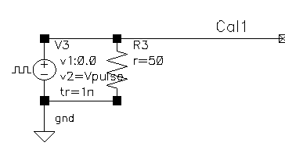e

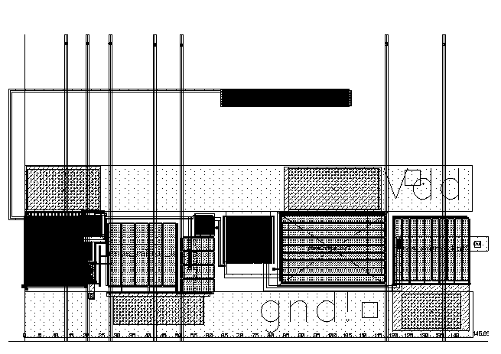
AFP_opt_channel
Injection Capacitance

