

**Instrumentation Development Laboratory**

**XRM**

Preamplifier Test Report

|  |  |
| --- | --- |
| Authors: L.V. Virta, P. Orel |  |
| Checked by: Gary S. Varner |  |
| Approved by: Gary S. Varner | Monday, September 28, 2015 |

**Table of Contents**

1 Introduction 3

1.1 Requirements 3

1.2 PSA4-5043+ characteristics 4

2 Simulation results 6

3 Measurement results 10

3.1 Test setup 10

3.2 Test results 11

3.2.1 Gain 11

3.2.2 Input return loss 13

3.2.3 Output return loss 14

4 Summary 15

5 References 15

# Introduction

In the XRM project, the input signal is from a narrow pulse with a wide dynamic range spanning small to large signals. To accommodate this, a wideband low-noise pre-amplifier is needed. At the same time, we are limited in detector box space and power density so we need to make the pre-amplifier with as small a footprint we can and low power consumption.

For this reason, we set out to search, identify such amplifiers, and conducted tests with different amplifier biasing configurations in order to identify the minimum workable footprint.

## Requirements

The frequency range spans at the low end of approximately 250MHz (app. 4ns) to the high end of 3GHz (due to possible future upgrade to the RFpix waveform sampler). It should not be lower than 1.5GHz, due to pulse shaping.

The desired dynamic range spans approximately from 3ke- to 15Me-. The pulse width has taken from [1] as being approximately 1ns to 10ns. We assume a 50Ω termination. So by using the following relation:

$$Signal \left[V\right]=\frac{N_{e}∙e}{∆t}R$$

$$where R=50Ω, e=1.602∙{10}^{-19}, ∆t is the pulse width and N_{e} is the number of electrons$$

So the signal range spans form the smallest one of approximately 2.7µV for 9ns pulse width to 120mV for 1ns pulse width as shown in Figure 1.

|  |  |
| --- | --- |
|  |  |

Figure : Small signal limit (left) and Large signal limit (right) of the input signal vs pulse width

Signal span is shown in figure 2:



Figure : Signal span vs pulse width

As we can see the signal dynamic range is more than 45000x or 93dB. However if limits to cases of 1ns pulse width the dynamic range is around 5000x or 74dB. The smallest amplitude in the latter case is around 24µV. To be able to see this kind of amplitude we require a very low noise amplifier with noise figure below 1dB.

We determine that the MinicircuitsPSA4-5043+ is the best option.

## PSA4-5043+ characteristics

The PSA3-5043+ is a low noise, high IP3 Monolithic E-Phemt amplifier with bandwidth spanning form 50MHz to 4GHz and noise figure of around 0.75dB. It can be driven form 3.3V or 5V respectively. It also has a declared gain of 18.4dB at 1GHz but varies over the frequency range. P1dB is around 20dBm and its IP3 is around 32dBm. It is internally matched to 50Ω on both input and output.

The figure 3 summarizes the characteristics:

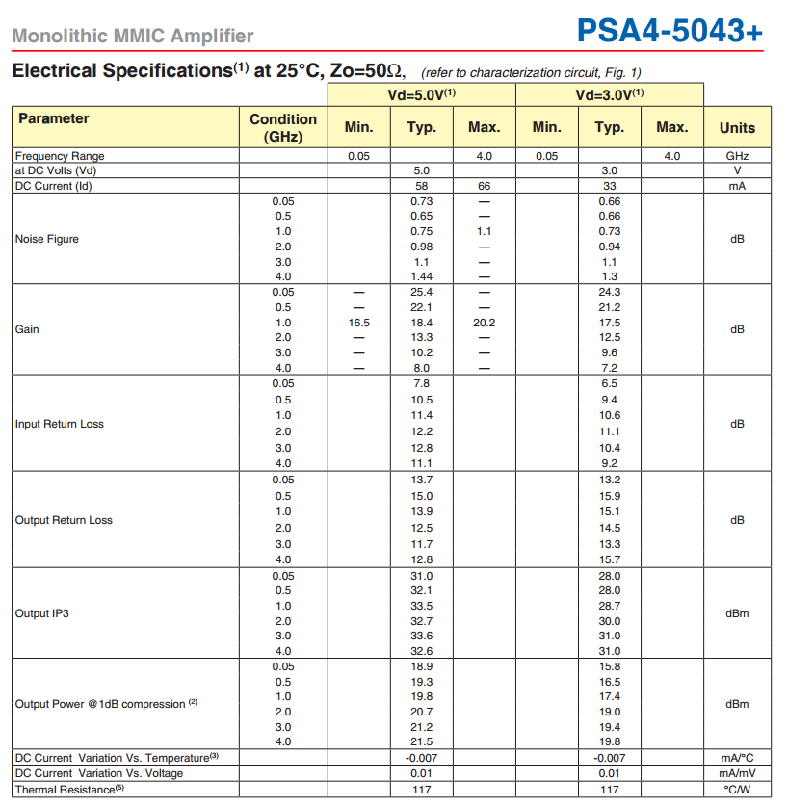

Figure : PSA4-5043 characteristics [2]

# Simulation results

Simulation has been done in the Keysight ADS simulation environment. We took into account the real model of inductor we wanted to use as well as coupling capacitors.

Figure 4 shows the schematic of the simulation:

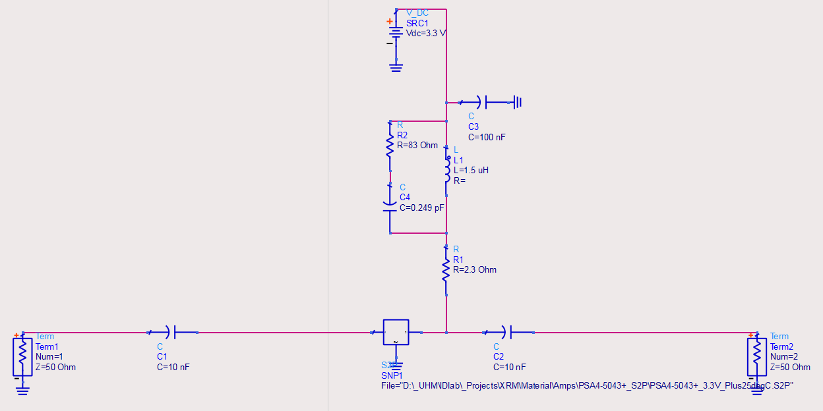

Figure : Schematic of the simulation

The results are shown in the following figures:



Figure : Input and Output return losses (Smith chart))



Figure : Input and output return losses (Mag-Log plot)



Figure : Gain plot vs frequency

As we can see gain variation is significant over the frequency range which will impact the pulse shape.



Figure : Stability factor

The amplifier is stable over the entire frequency range (figure 8).

# Measurement results

## Test setup

The measurements were done using Mini-Circuits TB-653+ evaluation board, which includes the PSA4-5043+ amplifier. The tests were done five times with five different inductors to see which set up works the best. Additionally, all test setups were tested on 3.3V and 5V rails. The motivation for testing the amplifier with different inductors is to get rid of the big inductor in testing circuit, more specifically replacing it to smaller one and reducing the layout space of the circuit.

Test equipment:

* Power Supply: Protek 3203
* Voltmeter: Fluke 179
* Evaluation board: Mini-Circuits TB-653+
* Vector Network Analyzer: PNA-L N5230C

|  |  |  |  |  |  |
| --- | --- | --- | --- | --- | --- |
| Test setup: | Setup1 | Setup 2 | Setup 3 | Setup 4 | Setup 5 |
| L | Original, TCBT14 bias tee | 0603HL-152XJRB | 0603HL-122XJLB | 1008CS-152XJLB | 1008PS-152KLB |

Table 1: Inductors for different measurements

## Test results

The testing results are divided into three different categories: Gain, Input return loss, and output return loss.

### Gain

The gain can be realized from the S21 parameter, which is a ratio of the output power over input power. The figure 9 shows the gains for all measurements.



Figure : S21 gain for 3.3V and 5V test setups

**

Figure : Gain comparison, test setup 1

As can be seen in Figure 10, there is no significant difference in gain between different power levels; this applies for all different test setups. Thus, the 3.3V power is superior choice for this project due to the decreased power consumption. In this case, measurements 1 and 4 seems to be the best choices in measure of gain. However, since measurement 1 is done with the original bulky inductor, the test setup 4 is the best choice in terms of the gain.

### Input return loss

The Figure 11shows the graph for input return loss for different test setups. In this case, the setups M3, M4, and M5seems to be the best choices in measure of input return loss. Since the M4 additionally has the best gain of all other setups, it makes M4 the best choice regarding the gain and input return loss.

**

Figure : Input return loss for 3.3V and 5V test setups

### Output return loss

The figures 12 and 13 (close-up) shows the graphs for output return loss. As can be seen, the test setups M2 and M4 are the best choices in terms of output return loss. Since M4 is the best candidate in terms of gain and input return loss, we can conclude that M4 is the best choice in all analyzed terms.

**

Figure : S22 Output return loss for 3.3V setups

**

Figure : S22 Output return loss for 3.3V setups (Close-up)

# Summary

The testing and analysis were done to find the best possible replacement for original, bulky, inductor used in using Mini-Circuits TB-653+ evaluation board. The reason for replacement is to reduce already limited layout space in design. As a test result from gain, input, and output return loss tests, the test setup M4 with 1008CS-152XJLB inductor seems to be the best choice.

# References

[1] <http://www.phys.hawaii.edu/~idlab/taskAndSchedule/xFEL/TEDA_DetectorDAQ_July2013.pdf>

[2] <http://www.minicircuits.com/pdfs/PSA4-5043+.pdf>